1. First of all create your workflow.

2. Add two approvers to this workflow by adding two steps.

3. After completing the process of making the workflow.

4. Make a temp table.

1. for creating a Temp Table.

2. Make a new table same as we do to make a regular table.

3. Expand the AOT > Data Dictionary > Tables.

4. Right click Tables and create a new table.

5. Right click the newly created table and open its properties.

6. Change the property "TableType" of Table to "TempTable" to make it a Temproray Table.

7. Compile and Save the table.

8. Add two string fields "Name" and "Comments" to this table.

9. Again Save and Compile the Table.

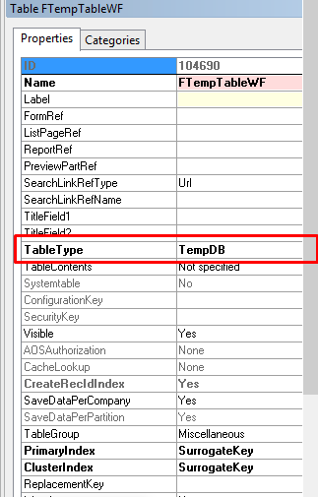

5. Add this temp table that you have created in the last step into the data source of the form of the workflow.

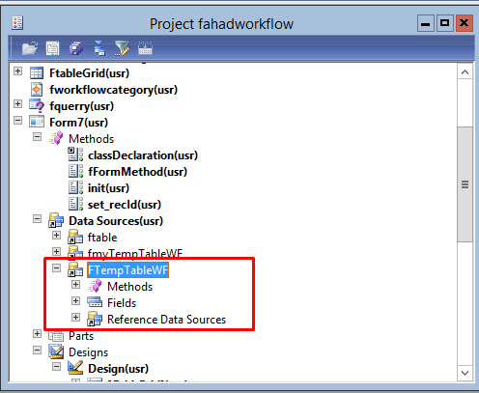

6. After this make a new grid into this form and drag the fields of the temp table (Name and Comments) to the grid.

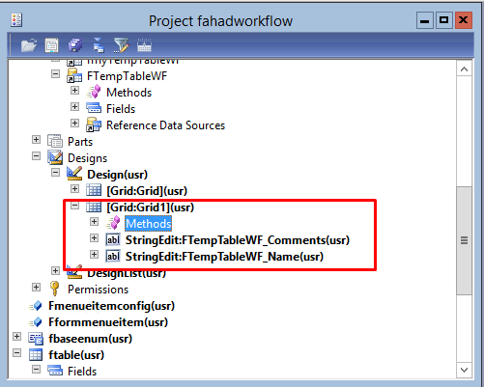

7. Make sure to change the DataSource name of the newly added grid to the name of the tempTable that you created in the step:4.

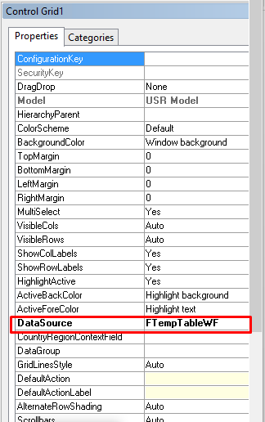

8. Compile and save the form.

9. After this add the code below into the class declaration of the form that you are using for the workflow.

public class FormRun extends ObjectRun

{

int64 RecID;

}

10. Make a new method in the form scope and add the code show below into this method.

public FTempTableWF fFormMethod()

{

MultiSelectionHelper selectionHelper = MultiSelectionHelper::construct();//Create instance of class

Set selectedRecords = new Set(Types::Record);//Declare a set of type record

ftable tableLines; //Your table buffer

Args args;

FormRun formRun;

RecId rec;

container conRecIds;

str temp_string;

FTempTableWF myTable;

workflowtrackingstatustable workflowtrackingstatustable;

WorkflowTrackingTable workflowtrackingtable;

WorkflowStepTable WorkflowStepTable;

WorkflowTrackingWorkItem workflowTrackingWorkItem;

WorkflowTrackingCommentTable workflowtrackingcommenttable;

WorkflowWorkItemTable workflowWorkItemTable;

WHILE select workflowtrackingstatustable

join workflowtrackingtable

//join workflowtrackingcommenttable

where workflowtrackingstatustable.ContextRecId == RecID

&& workflowtrackingstatustable.ContextTableId == tableNum(ftable)

&& workflowtrackingstatustable.TrackingStatus == WorkflowTrackingStatus::Completed

&& workflowtrackingtable.TrackingContext == workflowtrackingcontext::WorkItem

&& workflowtrackingtable.TrackingType == workflowtrackingtype::Approval

&& workflowtrackingtable.WorkflowTrackingStatusTable == workflowtrackingstatustable.RecId

join workflowtrackingcommenttable

where workflowtrackingcommenttable.WorkflowTrackingTable == workflowtrackingtable.RecId

{

myTable.Name = SysWorkflowHelper::getDirPartyNameFromUserId(workflowtrackingtable.USER);

myTable.Comments = workflowtrackingcommenttable.Comment;

myTable.insert();

//info("User: "+SysWorkflowHelper::getDirPartyNameFromUserId(workflowtrackingtable.USER));

//info("Comment: "+workflowtrackingcommenttable.Comment);

}

//info(strFmt('Selected record.. %1',tableLines.RecId));//Display selected record

return myTable;

}

11. After this override the init method of the form by the code below.

public void init()

{

ftable temp;

select * from temp;

RecID=temp.RecId;

super();

}

12. After this make a new method in the form scope and paste the code below.

public void set_recId(int64 _RecId)

{

RecID= _RecId;

info(strFmt("Got Rec ID %1",RecID));

}

13. After this override the init method of the TempTable by the code shown below.

public void init()

{

FTempTableWF Temp;

// Check for passed arguments

super();

//FTempTableWF_ds.DataSourceMethod();

//FTempTableWF.doInsert();

Temp=element.fFormMethod();

FTempTableWF.linkPhysicalTableInstance(Temp);

FTempTableWF_DS.research();

//

}

14. After this override the grid method (mouse Down) of the grid (first/above grid) that we are using for our workflow by the code shown below.

public int mouseDown(int _x, int _y, int _button, boolean _Ctrl, boolean _Shift)

{

int ret;

fmyTempTableWF myTable;

MultiSelectionHelper selectionHelper = MultiSelectionHelper::construct();//Create instance of class

Set selectedRecords = new Set(Types::Record);//Declare a set of type record

ftable tableLines; //Your table buffer

selectionHelper.parmDataSource(ftable_DS); //Set the datasource

tableLines = selectionHelper.getFirst(); //assign to table buffer the reference to selected record(s)

ret = super(_x, _y, _button, _Ctrl, _Shift);

info(strFmt("%1",tableLines.RecId));

element.set_recId(tableLines.RecId);

FTempTableWF_DS.init();

return ret;

}

14. Compile and save the form.

15. Run the form and click any record of the first/above grid you will see the names of the all approvers and their corresponding comments of the selected record into the second/below grid.

